**Project Design Phase-II**

**Data Flow Diagram & User Stories**

|  |  |
| --- | --- |
| Date | 29 October 2022 |
| Team ID | PNT2022TMID02120 |
| Project Name | |  | | --- | | Deep Learning Fundus Image Analysis for Early Detection of Diabetic Retinopathy | |  | |
| Maximum Marks | 4 Marks |

**Data flow Diagrams:**

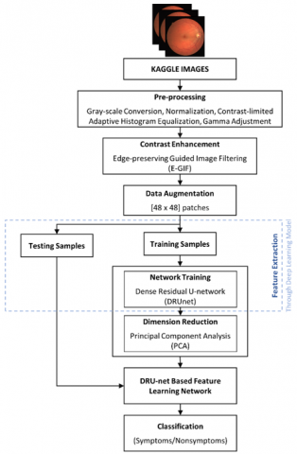

**User Stories**

* The retinal fundus images are commonly used for detection and analysis of diabetic retinopathy disease in clinics.

• Pre-processing of raw retinal fundus images are performed using extraction of green channel, histogram equalization, image enhancement and resizing techniques.

• The segmentation of retinal vasculature from eye fundus images is a fundamental task in retinal image analysis.

• The computer aided automatic detection and segmentation of blood vessels through the elimination of optic disc (OD) region in retina.

• The retinal blood vessels are detected using mathematical binary morphological operations.

• Feature extraction from the fundus images for the diagnosis of Diabetic Retinopathy refers to an advanced eye screening technology by which eye related diseases can be detected at an early stage.

|  |  |  |  |  |  |  |
| --- | --- | --- | --- | --- | --- | --- |
| **User Type** | **Functional**  **Requirement (Epic)** | **User Story Number** | **User Story / Task** | **Acceptance criteria** | **Priority** | **Release** |
| Patient (Web user) | Registration | USN-1 | As a user, I can register through website either email id or phone number with  password. | I can create my account. | High | Sprint-3 |
|  | Login | USN-2 | As a user, I can login to the site by the given  Login credentials. | I can login and access my  account. | High | Sprint-3 |
|  | Upload  image | USN-3 | As a user, I can upload my data in the form  of pdf, doc etc. | I can upload my data's. | Medium | Sprint-3 |
| Administration (Web  developer) | Admin login | USN-4 | As an Admin I can login to the site and  analyze the user data. | I can login and analyze  the user data. | High | Sprint-3 |
|  | Data  collection | USN-5 | As an admin, I can collect the dataset related  to the DR from source. | I can collect the dataset. | Low | Sprint-1 |
|  | Create model | USN-6 | As an admin, I can create the model and train the model from the dataset for  prediction. | I can create and train the model. | High | Sprint-1 |
|  | Test the  model | USN-7 | As an admin, I can test the model for  prediction. | I can test the model. | High | Sprint-2 |
| Patient (Web user) | Diagnosis | USN-8 | As a user I can get the diagnosis result on the application and follow up with treatments. | He/she can get the results  and continue the treatment. | High | Sprint-2 |